Teaching with Immersive Technology

Faculty Guide

*This document has a Table of Contents for easy navigation.*

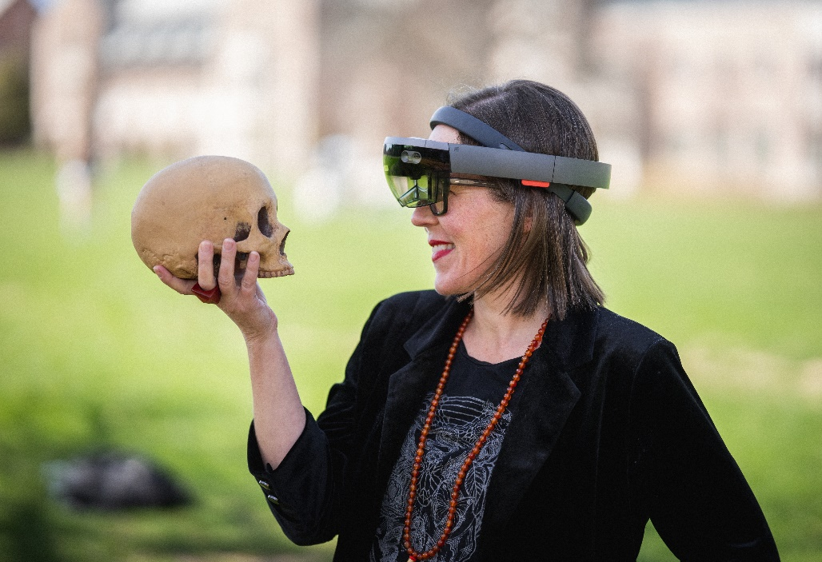

[Elizabeth Hunter, assistant professor of drama at Washington University in St. Louis](https://artsci.wustl.edu/ampersand/theater-augmented-reality-technology-bridges-audience-and-stage) *uses AR so audiences can immerse themselves and their environment into a theater performance through the POV of one of the play’s characters.*

# INTRODUCTION

## To immerse or not to immerse…is that the *only* question?

Hamlet struggled with reality and “words, words, words.” But now we have words, images, sound, tactile control, etc. Don’t get caught in the mire, let the [eLearning Division](https://www.sinclair.edu/academics/divisions/elearning-division/) assist you with the analysis, decision making, production, and implementation of immersive learning.

Below is a guide to help you get started and give you some context around the immersive experience and how to create such experiences. The term “real world” will be used to represent the physical world we inhabit.

What is immersive technology and immersive learning? First, let’s start with “immersion.”

## What is immersion?

From ancient cave paintings in the round to the first head-mounted display for simulations in 1960, the desire to create immersive experiences is nothing new for us humans. In between those times, humans experimented with panoramic paintings and stereoscopic photos, leading to the first flight simulation in 1929. The immersive technologies we know today first appeared in the 1980s. Visit the [History of Virtual Reality](https://www.vrs.org.uk/virtual-reality/history.html) on the Virtual Reality Society site which is a good source of info on tech, research, guides, and news.

According to Bjork and Holopainen, there are four types of immersion experienced by users in game play and other activities. One or more of these immersion types can be experienced by participants of immersive learning.

* Sensory-motoric immersion occurs when the user’s repetitious movements cause an expected feedback loop. Examples are an athlete practicing a drill or a pianist practicing a song; both require repeated movements to achieve the feedback expected by the user (athlete or pianist).
* Cognitive immersion occurs when the user’s abstract reasoning is used for complex problem solving. Examples are playing a chess game or constructing/deconstructing a puzzle.
* Emotional immersion occurs when the user responds to characters’ experiences within an unfolding narrative. Examples are the experience of reading a book or watching a movie.
* Spatial immersion occurs when the user experiences a simulated environment that is completely and perpetually convincing.

## What is immersive learning?

Immersive learning is simply the use of immersive technologies for learning. According to Jeremy Bailenson, there is some evidence regarding VR use for immersive learning. VR use can change a learner’s engagement/attitude in a positive way but can’t necessarily increase a learner’s assessment scores.

## What are immersive technologies?

You most likely have heard of virtual reality, or “VR.” However, there are many types of technologies, here are the most common ones with a definition from the [Franklin Institute](https://www.fi.edu/difference-between-ar-vr-and-mr), and an example image.

**Virtual Reality (VR)** is a complete immersion experience that shuts out the physical world. Using VR devices, such VR goggles/glasses and hand controllers*, users can be transported into a number of real-world and imagined environments such as the middle of a squawking penguin colony (video or animated) or a fantasy game world as pictured below.

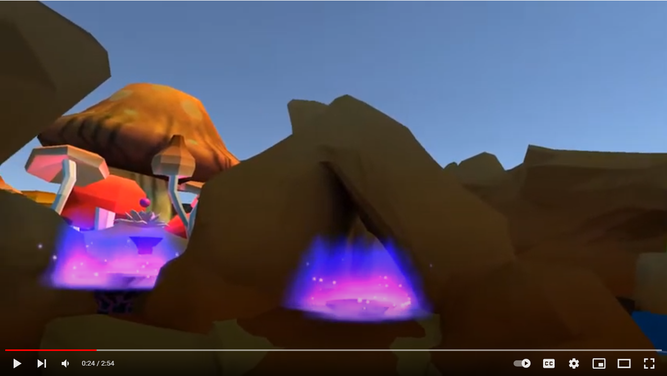

This is a still taken from the computer screen of the game from the user’s point of view (POV), it is an animated landscape of the [Landmark College student-produced VR game to teach statistics](https://www.youtube.com/watch?v=GrbSh4zq9o8).

**Augmented Reality (AR)** adds digital elements to a live view of the real, physical world for users with VR or AR devices*.

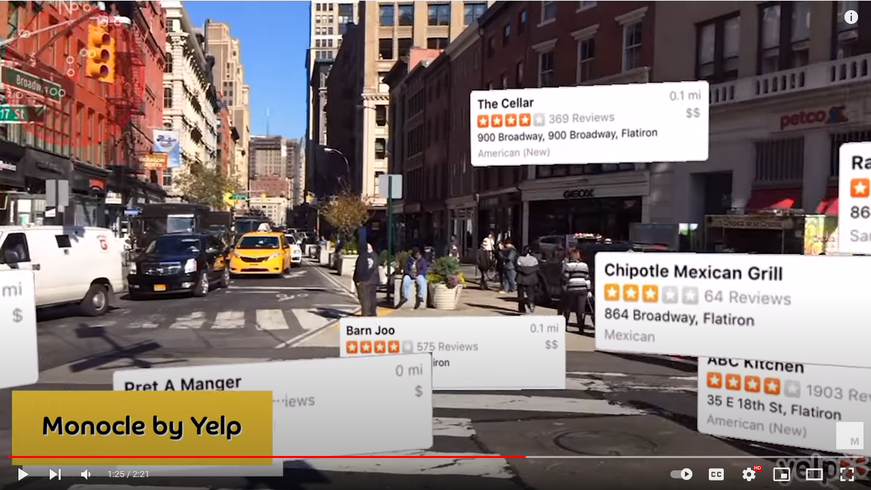

This is a still taken from the computer screen of a Yelp app from the user’s point of view (POV) in this [Mashable Explains video about AR](https://www.youtube.com/watch?v=XX993jgeQ0M).

**Mixed Reality (MR)** combines elements of both VR and AR, where real-world and digital objects interact. Typically, only goggle devices are used while the users' hands suffice as “controllers.”

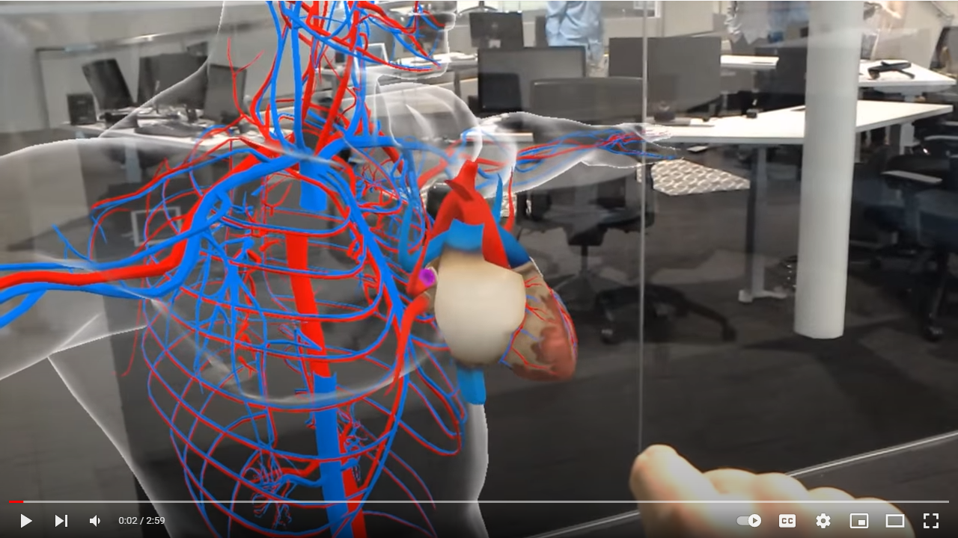

This is a still taken from the computer screen of the [HoloAnatomy MR experience](https://www.youtube.com/watch?v=h4M6BTYRlKQ) from behind the user’s point of view (POV). See the user’s hand “pulling” the heart out of the human model.

You may come across the term **Extended Reality (XR)** which refers to any or all the above technologies for extended periods of use.

*You don’t have to use special devices for immersive experiences! All immersive experiences can be translated to the customary desktop or laptop computer without immersive devices. It’s not as immersive or effective but it can give you an idea of the content and how it works, and it is a viable option if students can’t access immersive devices such as goggles/glasses or controllers.

**360 video**, referring to 360 degrees, is prominent in immersive learning. It can be used in all the reality types listed above, typically as the environment backdrop where the user engages with digital objects. 360 video is the easiest “first step” into immersive technologies and can be productively used without immersive devices (goggles and controllers) but simply on a customary desktop or laptop computer. Note that most VR, AR, and MR environments are in 360 degrees so users can perceive an environment all around them.

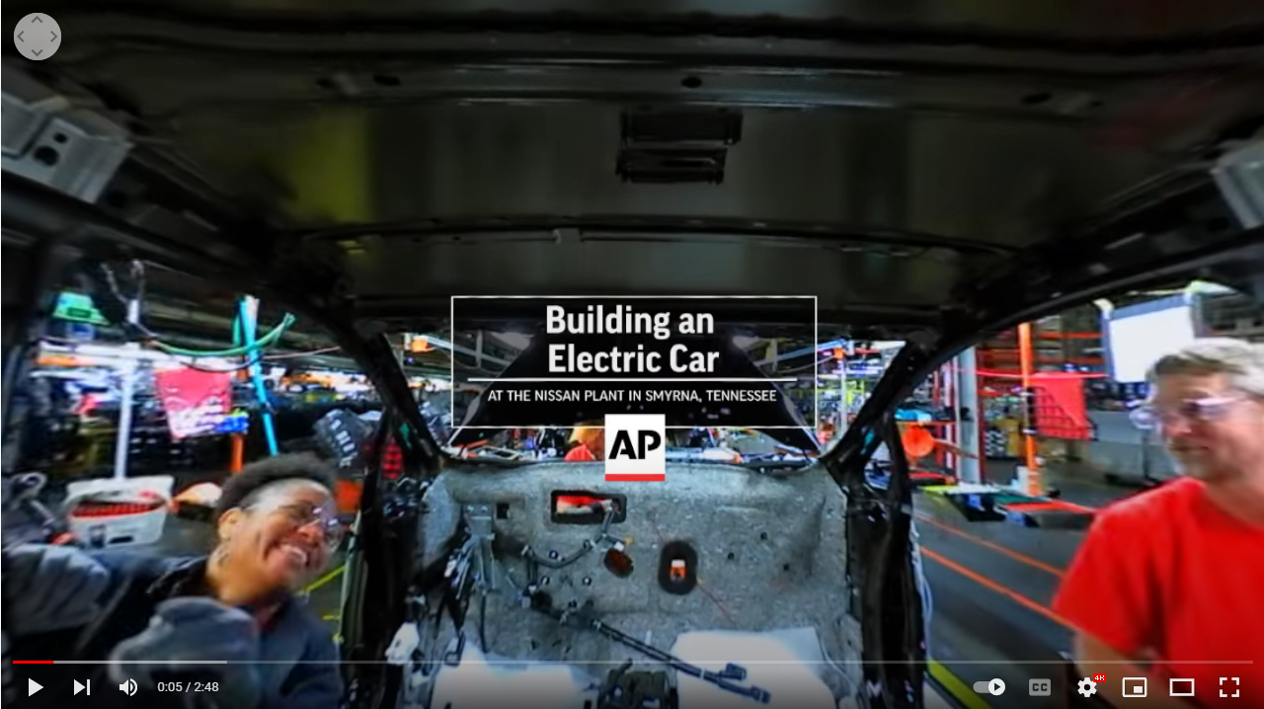

This is a still taken from the computer screen of an [AP-VR360 story](https://www.youtube.com/watch?v=6wsrpi-rxqU) from the user’s point of view (POV). The experience illustrates the building of a car through the assembly line. Notice the navigation icon in the upper left corner, the mouse can be used to navigate the 360 degree environment as well.

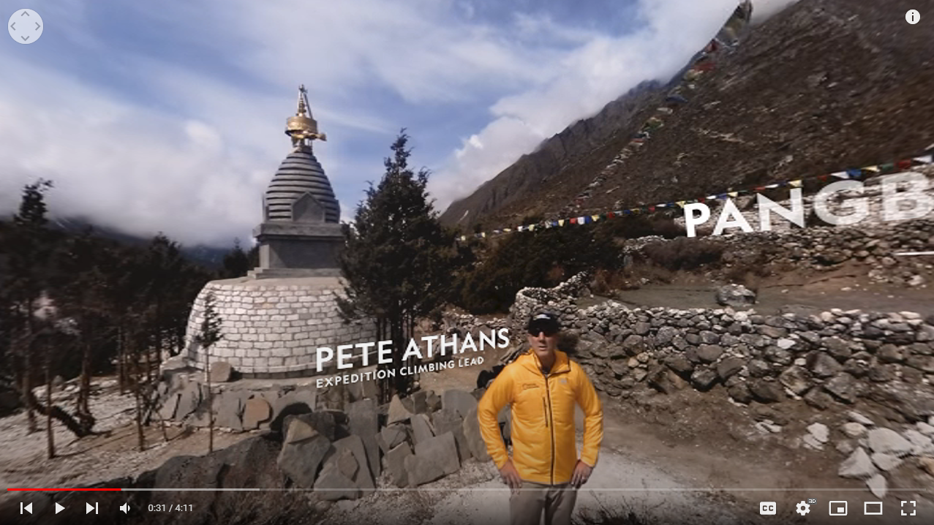

This is a still taken from the computer screen of [National Geographic’s Expedition Everest: The Mission - 360 story](https://www.youtube.com/watch?v=KM6HWp_ik2c&list=PLivjPDlt6ApRq22sn082ZCC9893XtV8xc&index=7). Notice the slightly curved edges and markers to guide the user through the 360 degree environment.

# POINTS TO PONDER

Questions and considerations to ponder before starting out:

## Questions and Considerations

* **Does it need to be immersive?** Use immersive technology for learning experiences that you can’t do in the real world but not for ones you *wouldn’t* do in the real world. Good for learning dangerous activities such as flying, driving, police work, etc. Cost must always be considered, and always research the benefit/deficit on immersive vs. real world.
* **How should the user’s journey be guided?** According to Bailenson, “VR is a democracy” because the user can shift gaze and interactions at their whim. If you need to control focus for learning or task-oriented purposes, you need to install that focus within the immersive experience. The immersive experience is about “exploration.” Use cues such as spatialized sound, movement, lighting, and/or markers or hotspots to guide the user’s gaze and action throughout the desired learning experience. Users can be positioned as embodied actors within the experience or as an invisible “ghost” observing the experience. Use minimal vocal narration unless it augments what is in the user’s view, written cues can be used in lieu of vocal narration as well. Exploration can be used as a benefit by forcing the user to find an object or part of an image which “makes the educational experience more interactive,” according to Miller-Foster in Jeffrey R. Young’s EdSurge article. If using a limited number of immersive technologies with a group of students, Ham (also in Young’s article) plans “waiting activities,” like preparing a critique of another student’s work before waiting to see yet another student’s work.
* **What about health, safety, and ethics?** Bailenson warns of simulator sickness and physical space issues. When a human moves it expects vestibular and proprioceptive cues of movement (sensations in the inner ear, skin, and muscles) and a change in optic flow (for example, “if you walk closer to a rock, it gets bigger in your field of view”).  It is ideal to have the physical room size match the virtual space size being explored by the user. This can be difficult if users are using devices in different sized rooms (someone may be in their bedroom while others might be in a gymnasium). Make sure the immersive experience is designed with the appropriate movement cues and space accommodations (some experiences allow users to “teleport” or instantly jump to an area). Otherwise, make sure the users are aware of the space issue. Good alternatives are to have “spotters:” people close by who can catch or guide users around physical obstacles. Also, you can provide a desktop/laptop video alternative where goggles/glasses don’t have to be used at all. Above all, keep the experiences short, around 10-15 minutes so users can better maintain their own health and safety. According to Mehendale, scholars tout that immersive technologies can generate a high level of empathy, but empathy that intense can generate distress as well. This can lead to other issues, such as post-experience disturbances and information overload, discussed by Slater, et. al. Keeping the experiences short will help reduce these disturbances and overload.
* **Is it already out there?** There is a plethora of existing content to either use in its entirety or to repurpose for your own use. Below are annotated lists of resources with shareable and usable content by subject area and type. See “What Others Are Doing by Subject” and “More Resources”. Note, you may find useful content in subject areas other than your own.

## What does it all entail?

Whether you want to experiment on your own or need a production team, [eLearning Division](https://www.sinclair.edu/academics/divisions/elearning-division/) can help.

Watch this story about the [process of developing immersive technologies for learning using geology as an example](https://www.youtube.com/watch?v=bNhFNw-Lgao) (the department is using MR but the production process is similar for all immersive technologies).

See how VR is developed using [the Timelooper app with history as an example](https://www.youtube.com/watch?v=PJ5Ie-wNfKI). Also, see how to view the app: 2:58-4:57 and 5:52-7:55.

Watch this [Mashable Explains](https://www.youtube.com/watch?v=XX993jgeQ0M) video with various examples illustrate how AR works.

With 360 video, you can click and drag with your mouse on the video or use the dial icon in the upper left corner of the video. This video about an [Everest expedition](https://www.youtube.com/watch?v=KM6HWp_ik2c&list=PLivjPDlt6ApRq22sn082ZCC9893XtV8xc&index=5) has text markers but shapes or icons can be used as well, like arrows. Or, see this self-guided 360 video tour of a [megaship](https://www.youtube.com/watch?v=nyk87htqu5k&t=26).

**Software listed below are free and available to you except for Articulate’s Storyline 360 which is available through the eLearning Division.**

### Create or download 3D object/image files.

You’ll need files to create your immersive environment and the objects that will reside there (such as [taking 360 photos with your phone](https://www.youtube.com/watch?v=bpLSE2rJfBg) or downloading 3D objects or image files from a repository like [Protein Data Bank](https://www.rcsb.org/)). If you are animating your own environment and objects (from scratch) using software, start at step 2. Or, you can use other common software to create your objects:

* Sketchup
* Tinkercad
* Sketchfab
* gimp or Photoshop
* CamTrackAR – to capture video for AR

Most used file formats:

* .jpg for 360 photos
* .mp4 (MPEG-4) for 360 videos
* .obj for 3D objects (these files are typically created in animation or design software)

### Prep the files for immersion in a 3D creation suite software.

[Blender](https://www.blender.org/) among others can be used. *Note: this step is not always necessary.*

### Import the files into a software to create a digital environment.

Import your files (animated and/or 360 photos/videos) in programs such as the Knight Lab’s [SceneVR](https://scene.knightlab.com/) or [Articulate’s Storyline 360](https://community.articulate.com/articles/360-images). Already have your objects in Blender (step 2)? You can continue using Blender, if you wish. If you are feeling confident and want to create an animated or complex environment, you can use a game engine such as [Unity](https://unity.com/).

### Export your experience as an MPEG-4 file (.mp4) or a device-specific app.

Once exported, you can play the file in a media player, such as VLC player or upload to a video streaming platform, such as Youtube for users without immersive devices. Apps are typically used for the device systems, goggles/glasses, and controllers.

### *Don’t forget about sound! Think “spatialized sound”*

Sound tends to be downplayed in immersive technologies as it is in cinema. Immersive sound experiences can be great for learning.

[Calling Thunder: The Unsung History of Manhattan](https://unsung.nyc/#home) is an immersive sound experience with 360 animation and video, a binaural audio recording--which gives a 3D stereo sound sensation with traditional 2D audio headphones--is included on the website). The designer of Calling Thunder is on the [ExFR'17: Audio & Voice](https://www.youtube.com/watch?v=e_4L2CunHN4) panel discussing the use of audio in immersive experiences.

[Immersed in Ethiopia: Using Immersive Media to Tell the Story of a Woman Who Is Blind](https://www.youtube.com/watch?v=vtbGR8KGq3Y) is an audio documentary where the audio is recorded using the ambisonic audio format (a 3D audio format improved from surround sound).

# WHAT OTHERS ARE DOING (BY SUBJECT)

Check out what others are doing in academia and beyond.

## Liberal Arts, Communication & Social Sciences

### Theater

Washington University in St. Louis

[Bitter Wind: A Greek Tragedy in Mixed Reality](https://www.youtube.com/watch?v=fMIScAsFhpg)

Promo video about theater performance in mixed reality which includes samples of user POV using the [Microsoft HoloLens](https://www.microsoft.com/en-us/hololens), an “AR device typically used for research applications.”

### Modern Languages

Carnegie Mellon University

[Across the Cut: Education in VR](https://www.youtube.com/watch?v=2aziXqngPNQ)

Promo video about foreign language immersive experience in virtual reality which includes samples of user POV.

### Communication

VirtualSpeech

[VirtualSpeech Presentation and Soft Skills Training](https://www.youtube.com/watch?v=pMK2dXK8EyY)

Video of user POV virtual reality samples. You can create a similar experience with 360 video of your face-to-face class for students to use to practice their speeches.

Stanford University

[Using Virtual Reality As a Compelling Media For Science Communication](https://mediax.stanford.edu/event/using-virtual-reality-as-a-compelling-media-for-science-communication/)

Presentation includes virtual reality samples of user POV.

### History

Newseum/Interface Media Group

[Berlin Wall VR Experience](https://samples.interfacemedia.com/berlinwallvr/)

National Geographic

[Wolin Viking Festival reenactments](https://www.youtube.com/watch?v=oNEW4qPacGw&t=3s)

University of Sydney and Lithodomos

[Ancient Theatre in Nea Paphos in Cyprus](https://www.youtube.com/watch?v=z1phTsh8zJc)

Videos of user POV virtual reality samples.

### Arts and Design

University of the Arts London and other institutions

The Accelerate Project

Promo video about a project in progress in virtual reality which includes samples of user POV.

### Music

Illinois State University

[Musical Sandbox - music composition](https://www.youtube.com/watch?v=qxrumb-nSvU)

Promo video about a music composition immersion experience which includes samples of user POV.

[In Proceedings of the 2020 Human-Computer Interaction International Conference, J. Y. C. Chen and G. Fragomeni (Eds.), LNCS](https://doi.org/10.1007/978-3-030-49695-1_18), vol. 12190, July 19-24, 2020, pp. 275-285. <https://doi.org/10.1007/978-3-030-49695-1_18>

[Virtual Reality in Music Conductor Education](https://www.youtube.com/watch?v=0wY5gh8elq4)

Video includes samples of user POV.

### Geography

[Google Earth VR](https://arvr.google.com/earth/)

Use VR to walk around, fly, or browse Google Earth content.

## Health Sciences

### Nursing

VeinScanner and VeinSeek Pro apps for smartphones

[VeinSeek Pro: Vein Finder App for iPhone](https://www.youtube.com/watch?v=IpHdBOxDCRA)

This mobile app technology can “immerse” the view of the user into the veins of an individual.

Case Western and Cleveland Clinic

[HoloAnatomy app helps medical students learn anatomy](https://www.youtube.com/watch?v=gzUTT1Kygo4)

Video about the HoloAnatomy app developed by Case Western and Cleveland Clinic.

### Mental Health and Addiction Services

[Elderly and mental patients/patient communication](https://www.npr.org/sections/health-shots/2016/06/29/483790504/virtual-reality-aimed-at-the-elderly-finds-new-fans) (several)

### Rehabilitation Services

Recover Injury Research Centre

[Use of Virtual Reality in Rehab](https://www.youtube.com/watch?v=Aa4EC6Io3BU)

Video explains how VR is used to improve patient communication and rehab services.

### Dental Health Sciences/Surgical Technology

Mahidol-Bremen Medical Informatics Research Unit, Mahidol University

[Virtual training environments for dental surgery education](https://www.youtube.com/watch?v=q-B3lyGj3ok&t=1s)

## Business & Public Services

### Criminal Justice Training/Police Academy

[Street Smarts VR](https://www.youtube.com/watch?v=kF3CQ2C7PFg)

VR training for law enforcement and first responders.

### Hospitality Management & Tourism

[FlyOver Zone Virtual Tourism](https://www.flyoverzone.com/virtual-tours-2/)

[Employee Training - restaurant](https://www.youtube.com/watch?v=dKdthRRW6-8&t=3s) (from a local producer, [Designing Digitally](https://www.designingdigitally.com/portfolio/training-simulations/virtual-reality-simulation-pizza-making-process-employee-training))

### Real Estate

[Augmented Reality for home tours and assisting buyers](https://www.youtube.com/watch?v=xetdPntL92U)

### Management

[INSEAD’s exploration of business cases](https://www.youtube.com/watch?v=DIqCI_GUYjs)

## Science, Mathematics & Engineering

### Math & Engineering

[Landmark College Students Create VR Game to Teach Statistics](https://www.youtube.com/watch?v=GrbSh4zq9o8&t=1s)

[AR Merge Cube for Multiplevariable Calculus at Penn State University](https://imex.psu.edu/faculty/case-studies/math-230/)

### Chemistry

[Organic Chemistry Lab in 360 video – North Carolina State University](https://www.youtube.com/watch?v=nZ_Nh2yqKdU)

Other Chemistry examples, with VR molecules

[Molecular VR – University of Bristol](https://www.youtube.com/watch?v=EIt5hDSbRvg)

[Nanome – drug research](https://www.wsj.com/articles/virtual-reality-puts-drug-researchers-inside-the-molecules-they-study-11631023212)

### Astronomy

[Cat’s Eye Nebula VR from Nasa's Chandra X-ray Observatory](https://chandra.cfa.harvard.edu/vr/ar/Tours/cats_eye/cats-eye-ar.html), once started you will need to hit the escape key to regain control of the browser.

[Galactic center, also from Chandra](https://www.youtube.com/watch?v=wBxW2_B9_Is)

### Geology

[Ontario’s geology from the Oil, Gas & Salt Resources Library](https://www.youtube.com/watch?v=H_58g0dQ-Nc)

### Architectural Technology

[AR for architectural models - ARki app](https://www.youtube.com/watch?v=BqSix1c2XhE&t=1s)

### Mechanical Engineering Technology

[AR jet engine demo - JigSpace](https://www.youtube.com/watch?v=eSsjQ7wZOtw)

# RESOURCES

## Catalogs and Collections

[The Virtual World Heritage Lab](http://vwhl.squarespace.com/projects), part of [The Uffizi Digitization Project](http://www.digitalsculpture.org/florence/), is a partnership between the Uffizi Gallery in Italy and higher ed institutions around the globe (including Indiana University) to digitize [statues as 3D objects](https://sketchfab.com/3d-models/agrippina-minor-inv-1914-n-115-085eea8118f84a9b9982ac34daef95c7?utm_medium=embed&utm_source=website&utm_campain=share-popup) that can be used in VR technologies.

[The Immersive Experiences Lab at Penn State](https://imex.psu.edu/) (the IMEX Lab) has a [collection of resources](https://imex.psu.edu/experience-catalogue/) such as curated software, 360/180 experiences, VR experiences, and AR experiences. Their Experience Catalogue is categorized by subject and has experiences curated from many sources, including [Associated Press’ AP-VR360](https://www.youtube.com/channel/UCcm3OlUg5LGOaWxMBzd1QfA), [Frontline 360](https://www.pbs.org/wgbh/frontline/investigation/360-films/), [NYT’s Daily 360](https://www.nytimes.com/video/science/100000005594706/brains-hearts-and-heroin-addiction-medicine-in-vr.html?playlistId=video/the-daily-360), and [RMIT University’s Centre for Digital Enterprise](https://www.rmit.edu.au/news/c4de). These media can be used in courses or inspire new ideas for projects.

[Virtual Human Interaction Lab at Stanford University](https://stanfordvr.com/Downloads/) provides VR content in a variety of subject areas.

Mary Anne Funk of the [Oregon Reality Lab at the University of Oregon](https://journalism.uoregon.edu/oregon-reality-lab). created [a multimedia documentary experience with a focus on sound](https://www.seeingthroughhearing.com/). Different audio formats are explained, and samples can be downloaded.

[Google’s Arts & Culture Expeditions](https://artsandculture.google.com/project/expeditions) provides virtual field trips in a variety of subject areas including science and technology.

Washington University in St. Louis has [GeoBase](https://geobase-wustl.herokuapp.com/) which provides 3D terrain models of Earth and other planets and the [GeoXplorer AR app](https://virtualplanet.wustl.edu/geoxplorer/).

[Pepin online: Virtual Museum Collection](http://trcf52.okstate.edu/pepin/index.html) in partnership with Oklahoma State University has interior design artifacts.

[National Geographic 360 Videos](https://www.youtube.com/playlist?app=desktop&list=PLivjPDlt6ApRq22sn082ZCC9893XtV8xc)

[Time Magazine Immersive App](https://time.com/longform/time-immersive-app/)

[NASA 360 Videos](https://www.youtube.com/user/FollowNASA360)

[NASA’s Chandra X-ray Observatory VR](https://chandra.cfa.harvard.edu/vr/)

## Objects

[Pimp My Drawing](https://pimpmydrawing.com/) is a free library of drawn 3d objects as DWG files (may need to be converted to use in Blender)

[3Dxo](https://www.3dxo.com/) has textures and photos in common file formats

[Xoio](https://xoio-air.de/2017/3d-scanned-people-improved-version/) has people cutouts

[Sketchfab](https://sketchfab.com/tags/educational) has 3D models specific for education

Sketchup has a [3D Warehouse](https://3dwarehouse.sketchup.com/) of objects

[Turbosquid](https://www.turbosquid.com/Search/3D-Models/free) has 3D models

[Cgtrader](https://www.cgtrader.com/free-3d-models) has 3D models

[Thingiverse](https://www.thingiverse.com/) has 3D models

[MorphoSource](https://www.morphosource.org/?locale=en) has 3D objects of natural history, cultural heritage, and scientific collections

Smithsonian [3D Digitization Collections](https://3d.si.edu/collections), see [Open Access Highlights](https://3d.si.edu/collections/openaccesshighlights)

[Cleveland Museum of Art 3D models](https://sketchfab.com/clevelandart/models)

## Spaces

[Mozilla Hubs](https://hubs.mozilla.com/) provide private 3D virtual spaces, see an example of virtual space: <https://hubs.mozilla.com/42u9Qpc/academy>

Research in the Region

[The Experience Design Lab](https://design.ncsu.edu/research/experience-design-lab/) at North Carolina State University focuses on research of immersive technologies.

[The HIVE](https://miamioh.edu/cec/academics/departments/cse/about/facilities/hive/index.html?_ga=2.262111877.946844022.1658959152-1940540517.1658959152) at Miami University focuses on research of spaces for immersive technologies.

[BuckeyeVR](https://buckeyevr.osu.edu/index.html) at The Ohio State University develops and researches classroom-ready VR solutions.

The [CARISMA Lab](https://www.carismalab.com/) at Michigan State University conducts research on effects of VR.

## Works Cited/Consulted

Bailenson, Jeremy. *Experience on Demand: What Virtual Reality Is, How it Works, and What It Can Do*. W.W. Norton & Company, 2018.

Mehendale, Sneha Gore. “Regarding Ethical Concerns about ‘Immersive’ Journalism.” *Media Ethics*, Fall 2020, vol. 32, no. 1, [www.mediaethicsmagazine.com/index.php/browse-back-issues/215-fall-2020-vol-32-no-1/3999319-reviewing-ethical-concerns-about-immersive-journalism](http://www.mediaethicsmagazine.com/index.php/browse-back-issues/215-fall-2020-vol-32-no-1/3999319-reviewing-ethical-concerns-about-immersive-journalism). Accessed 29 Sept. 2022.

Slater, et. al. “The Ethics of Realism in Virtual and Augmented Reality.” *Frontiers in Virtual Reality*, Sect. Virtual Reality and Human Behaviour, 03 March 2020, [www.frontiersin.org/articles/10.3389/frvir.2020.00001/full](http://www.frontiersin.org/articles/10.3389/frvir.2020.00001/full). Accessed 29 Sept. 2022.

Staffan Bjork and Jussi Holopainen. *Patterns in Game Design*. Charles River media, 2005. <https://books.google.com/books?id=IFQfyODK4wAC&newbks=0&hl=en&source=newbks_fb>

Young, Jeffrey R. “’Herding Blind Cats’: How Do You Lead a Class Full of Students Wearing VR Headsets?” *EdSurge*, 5 Apr. 2017, edsurge.com/news/2017-04-05-herding-blind-cats-how-do-you-lead-a-class-full-of-students-wearing-vr-headsets? Accessed 29 Sept. 2022.